SAP ABAP LEARNING REPORT

NAME : DHANUSH KADULURI.

TOPICS LEARNED LAST WEEK [ UPTO 30/04/2024 ]:

1. SAP and ABAP definitions.
2. Client – server architecture.
3. ERP definition, ERP process, ERP products and reasons to migrate with ERP.
4. Work processes ( just overview).
5. Taking inputs from users.
6. Standard tables.
7. Master and transaction tables.
8. Debugging.
9. ABAP dictionary ( SE11 ) and Buffers.
10. Types of tables.
11. Creating databases and inserting records manually.
12. Creating TMG’s on table.
13. Structures.
14. Views.
15. Search helps.
16. Joins.
17. Writing programs to display table data, joins, etc…,
18. Modularization technics.
19. Include.
20. Sub-routines.
21. Function modules.
22. Classic reports.
23. Events.
24. Formatting.

.

.

.

.

.

.

.

.

.

Following screenshots are my practices which may not be in above order.

CREATING DATABASE VIEW :

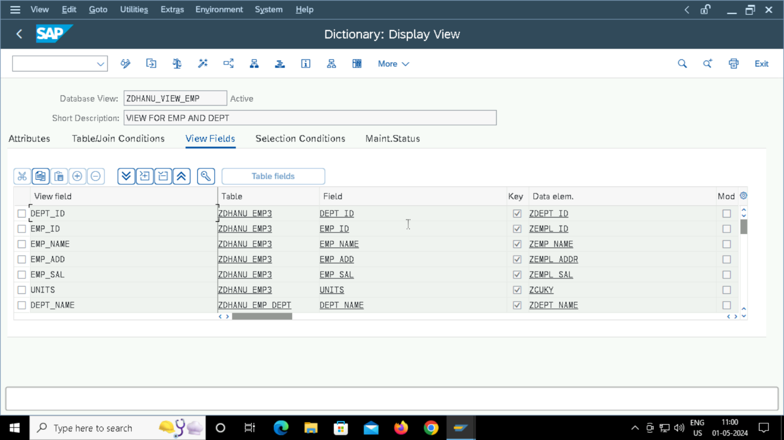

CREATING TABLE: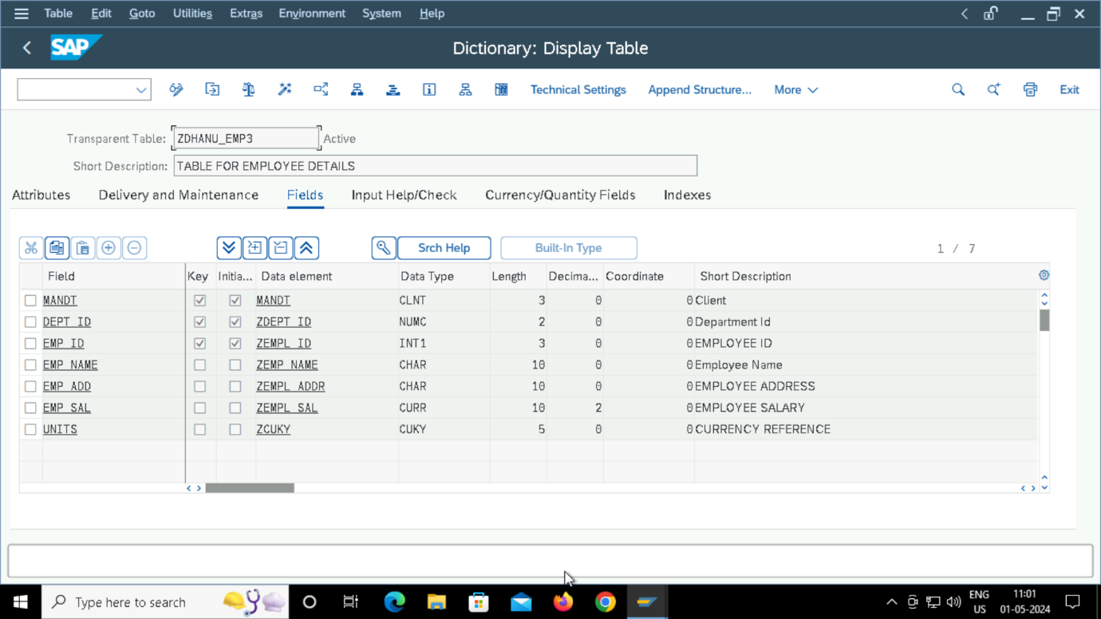TABLE RECORDS: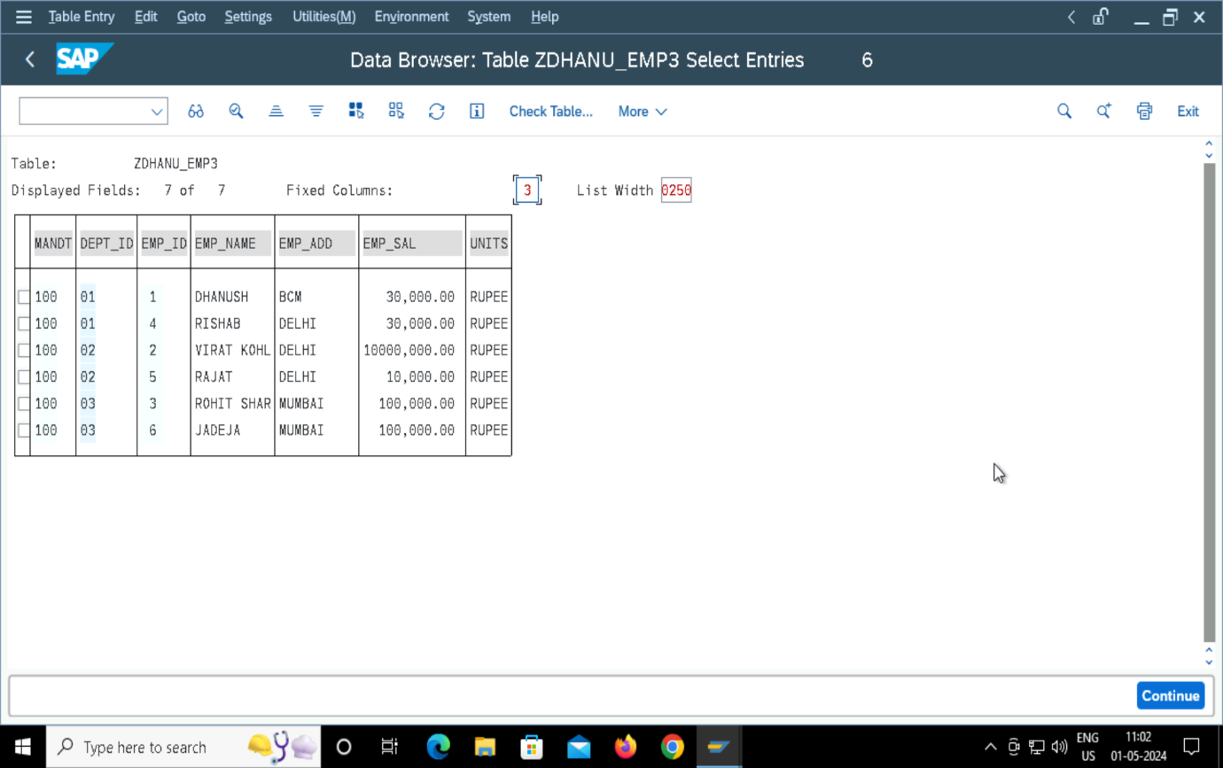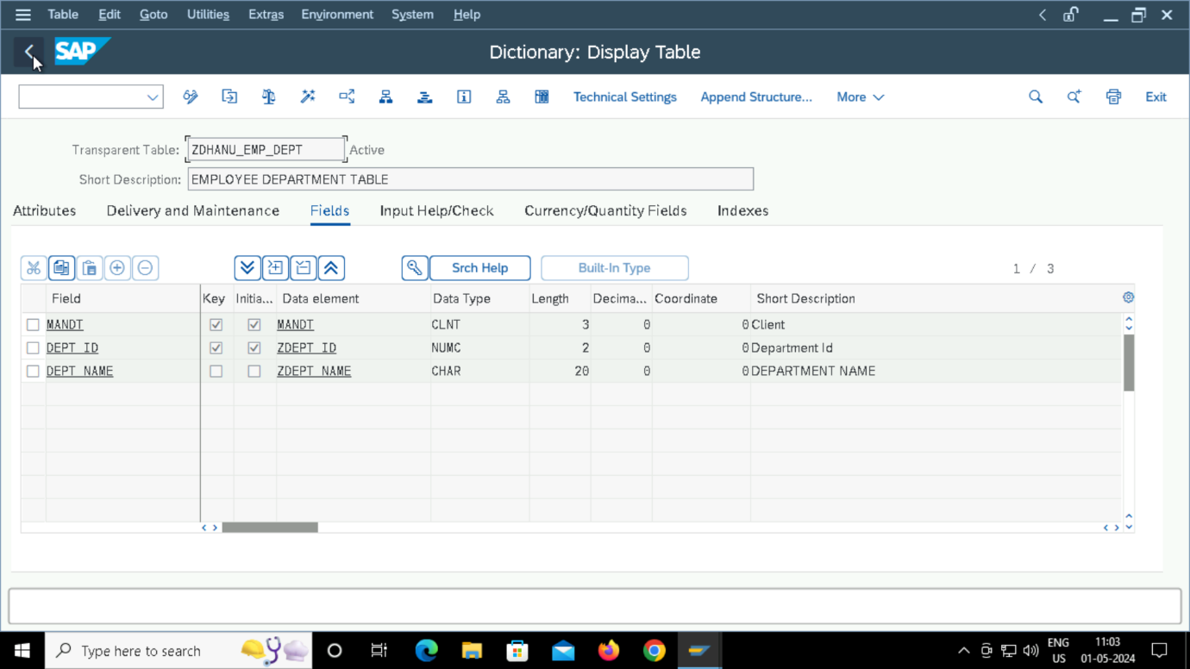CREATING FUNCTION MODULE: 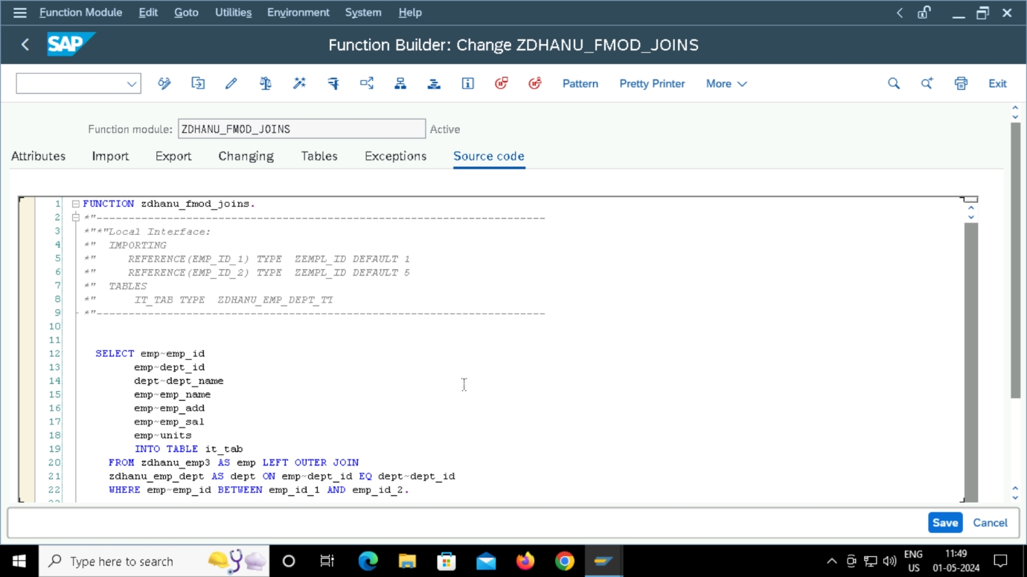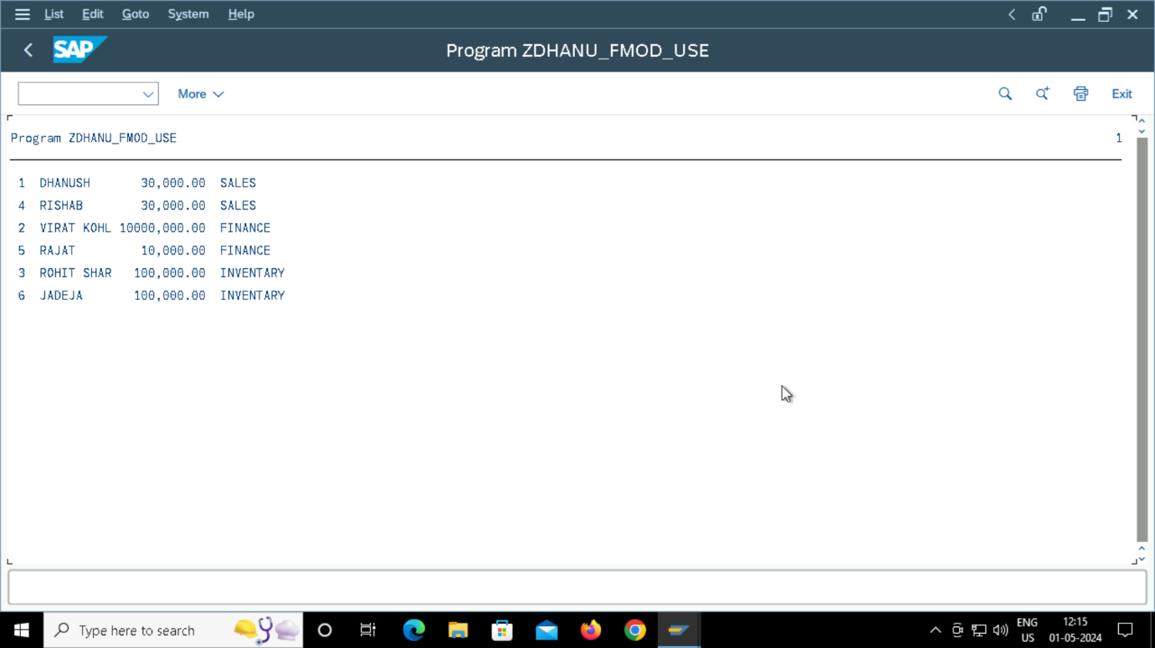

CALLING FUNCTION MODULE IN PROGRAM: